WWW.BTIGAUGES.COM

BTI Installation Guide For:
BTI TPMS I 500/1000
BTI TPMS E 500/1000
Rev 1.0

BTI TPMS INSTALLATION:
The BTI TPMS tire monitoring system is a plug and play addition to your BTI ECU to readily observe changes in tire temperature, pressure, and potential via CAN BUS. The monitoring system includes four sensors that can be installed within the tire interior or exterior depending on configuration preference. The BTI TPMS is available in four configurations:
- TPMS 500 – E
- TPMS 1000 – E
- TPMS 500 – I
- TPMS 1000 – I
TPMS Specs:
- Read up to 116psi (0 – 800 kpa)
- IP67 protection grade
- Simultaneous pressure and temperature measurement
BTI TPMS 500/1000 External Configuration:
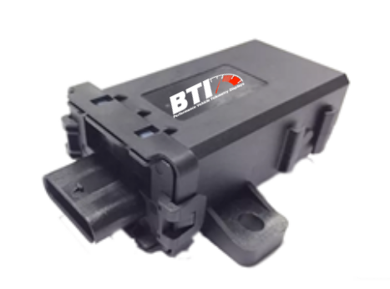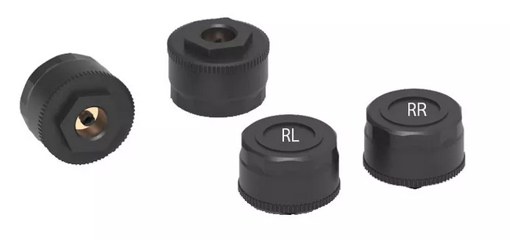
Receiver External Sensors
BTI TPMS Kit Includes:
- Digital Access Instructions
- TPMS Receiver
- Four External Tire Pressure Sensors
- Plug and Play Wiring Harness
- Mounting Kit
BTI TPMS 500/1000 Internal Configuration:
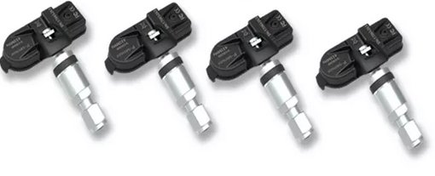
Receiver Internal Sensors
BTI TPMS kit Includes:
- Digital Access Instructions
- TPMS Receiver
- Four Internal Tire Pressure Sensors
- Plug and Play Wiring Harness
- Mounting Kit
Instillation Instructions:
Receiver:
Install the TPMS receiver using the mounting kit provided at the highest point available in the cabin for best communication results.
After mounting the receiver use the wiring harness provided in the TPMS kit to power on, at which point the receiver will emit an audible confirmation signal to indicate that the receiver has been successfully powered on.
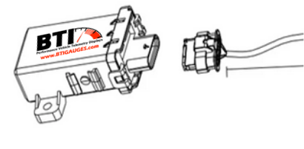
Receiver/ Harness connection
External Sensor Installation:
- Remove original valve cap from valve
- Inflate tire to preferred pressure
- Insert theft lock nut onto valve
- Identify the labeled external tire sensor and corresponding tire and install sensor in place of the original valve cap
- Ensure lock is secure by tightening with wrench provided in TPMS kit
- Conduct valve check with soapy water to check for potential leaks
- Repeat until all external sensors are successfully installed
Internal Sensor Installation:
- Deflate tire and remove from wheel
- Detach original tire valve from wheel
- Identify the labeled internal tire sensor and corresponding tire and install sensor in place of original tire valve
- Without disturbing valve, replace the tire on corresponding wheel
- Inflate tire to preferred pressure
- To ensure correct tire balance, conduct a dynamic wheel balance
- Repeat until all internal sensors are successfully installed

TPMS Warning Codes:
The BTI TPMS monitoring system will display optional diagnostic Trouble Codes, or DTC’s, upon deviation from preference via setup once a sensor is assigned to a specific tire:
- Loss of signal or sensor
- Air leak
- Change in air pressure (high or low)
- Low sensor battery voltage
- High temperature
High / Low PSI Warning:
A DTC for air pressure (psi) can be employed when the psi value of any sensor detects a value above or below the user set preferences of front / back tire pressure at a maximum value of 116 psi. Preferences are determined through a maximum and minimum value, and deviation outside of these parameters enables a DTC in less than thirty seconds of pressure change outside of the set parameters.
Potential Leak Warning:
A DTC can be employed for possible air leaks in sensor enabled tires. Leaks can defined via sensor prerequisites or user defined value parameters via the setup menu. The sensor will identify a potential leak when a pressure value drops at a greater rate than defined parameters. The signal will be conveyed in under thirty seconds of value change detection.

Signal Loss Warning:
A DTC is employed if an active sensor loses signal. For signal loss detection to occur tires must be in motion and vehicle speed must be active to facilitate sensor reading.
Low Voltage Warning:
Each sensor battery can be observed individually via the corresponding battery voltage channels, a DTC will be employed when the battery voltage of a sensor register as low (below 3.2 V.)
Wiring Your BTI TPMS:
The BTI TPMS kit includes a four pin wiring harness in each kit. This harness is attached to the receiver with the black connector. From there the harness connects to your BTI gauge with the white four pin connector at the opposite end of the wiring harness.
Receiver Wiring: DTM-4 Receptacle
PIN | Connection | Wire Color
1 | BATTERY GROUND | Black
2 | 12 V Supply | Red
3 | CAN Low | White
4 | CAN HIGH | Green
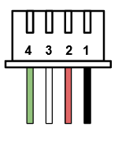
White Connector Wiring Diagram
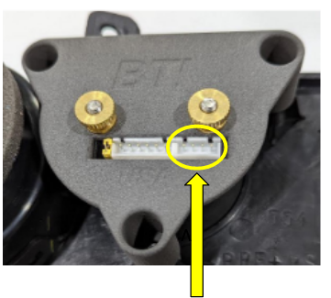
Insert white 4 Pin connector into back of BTI Gauge

Servicing Your BTI TPMS:
External Sensor Battery Replacement:
The BTI TPMS external sensors have an approximate battery life of one to three years and are replaceable with CR1632 batteries. The BTI TPMS internal sensors utilize a battery (CR2023) that is not replaceable however; they have a longer battery life than the external sensor of approximately four to five years.
BTI TPMS 500/1000 External Battery Replacement:
- Unfasten external sensor from valve stem
- Separate the sensor cover from the sensor
- Remove battery from sensor by pushing away from three pronged casing
- Replace with new battery (Battery Type: CR1632)
- Refasten sensor cover to sensor and replace onto corresponding valve stem
- Repeat as needed
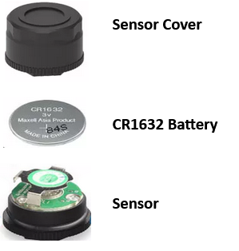
REVISION: DATA STREAMS
The data stream is as follows:
** All values listed in decimal**
------------------------------------------------------------“CAN 0”---------------------------------------------------------
Byte 0 (16 bits) Byte 1 (16 bits) Byte 2 (16 bits) Byte 3 (16 bits)
(MoTeC offset 0) (MoTeC offset 2) (MoTeC offset 4) (MoTeC offset 6)
- - - - - - - - - - - - - - - - | - - - - - - - - - - - - - - - - | - - - - - - - - - - - - - - - - | - - - - - - - - - - - - - - -
Boost Control 0 – 5000 Antilag Launch Valet
Divided by PWM Steps Off = 0 / On = 5000 Off = 0 / On = 5000 Off = 0 / On = 5000
Received as 0v - 5 v Received as 0v or 5v Received as 0v or 5v Received as 0 or 5v

TPMS data is received at address 0x77e hexadecimal (1918 decimal) and is in big endian format.
Byte 0 :Multiplexed by wheel (1=FL, 2=FR, 3= RL, 4=RR)
Bytes 1 & 2 (16 bit) = tire pressure kPa
Byte 3 = Tire Temperature °c
Byte 4 = Tire Voltage (multiply by .1)
Byte 5 = Negative multiplier for TPMS temp: byte 3. ( if the value of byte 3 = 1, multiply the temp by -1 )

BTI TPMS 500/ 1000 Internal Battery Replacement:
Batteries are not replaceable for this model.
BTI TPMS Operation Parameters:
Receiver Parameters:
Item | Technical Parameter
Input Voltage | DC 12V TO 32V
Working Current | Less 40mA
HF Receive Frequency | 433.9MHz±50KHz
HF Receive Sensitivity | Less - 105dBm
Working Temp Range | -40℃ ~ 125℃ or -40°F ~ 257°F
Data Transmission Mode | CAN-BUS
Baud Rate | 1000kbps/500kbps
RF Coding | Manchester

External Parameters:
Item | Technical Parameter
Battery Model No. | CR1632(140mAh)
RF Frequency | 433.92MHz±38KHz
Standby Current | Less 0.7 uA
Emisson Current | Less 8 mA
HF Emisson Power | Less 0 dbm(50Ω)
HF Modulation Rate | FSK
LF Frequency Rate | 125 KHz±5KHz
LF Modulation Rate | ASK
Pressure Measurement Range | 0-800kpa(0~116psi)
Temperature Measurement Range | -40℃ ~ 125℃ or -40°F ~ 257°F
Temperature Measurement Accuracy | ±4℃(0℃ ~ 70℃) or ±39°F(32°F ~ 158°F)
Working Temperature Range | -30℃ ~ 85℃ or -22°F ~ 185°F
Storage Temperature Range | -20℃ ~ 85℃ or -4°F ~ 185°F
Protection Grade | IP67
Battery Lifespan | Over 1 Year (Replaceable Battery)

Internal Parameters:
Item | Technical Parameter
Battery Model No. | CR2050(450mAh)
RF Frequency | 433.92MHz±38KHz
Standby Current | Less 0.7 uA
Emisson Current | Less 8 mA
HF Emisson Power | Less 8 dbm(50Ω)
HF Modulation Rate | FSK
LF Frequency Rate | 125 KHz±5KHz
LF Modulation Rate | ASK
Pressure Measurement Range | 0-800kpa(0~116psi)
Temperature Measurement Range | -40℃ ~ 125℃ or -40°F ~ 257°F
Temperature Resolution | 1℃ or 33.8°F
Temperature Measurement Accuracy | ±3℃(0℃~70℃) or ±37°F(32°F~158°F)
Working Temperature Range | -40℃ ~ 125℃ or -40°F ~ 257°F
Storage Temperature Range | -40℃ ~ 125℃ or -40°F ~ 257°F
Protection Grade | IP67
Battery LifeSpan | Over 5 Years

Warranty:
All BTI Gauges carry a 1 year warranty effective at the time of purchase.
• This warranty extends only to products distributed and/or sold by BTI Gauges.
It is effective only if the products are purchased and operated in the USA. (Within
the USA including US 48 States, Alaska and Hawaii.)
• This warranty covers only normal use of the computer. BTI Gauges shall not be
liable under this warranty if any damage or defect results from (i) misuse, abuse,
neglect, improper shipping or installation; (ii) disasters such as fire, flood, lightning
or improper electric current; or (iii) service or alteration by anyone other than an
authorized BTI Gauge representative.
• You must retain your bill of sale or other proof of purchase to receive warranty
service.
• No warranty extension will be granted for any replacement part(s) furnished to
the purchaser in fulfillment of this warranty.
• Warranty claims must be sent to sales@btigauges.com.

